Reg No: 2212352  Name: Saqlain Mushtaq | Assignment # 3  Date: 12-12-2025

Program | : BSCS | Class & Section | :BSCS 6A&B
Course Name | : Android Application Development
Instructor’s Name | : Muhammad Azhar | Marks | : /4
(CLO-3)

Develop an Android application that allows users to create and manage study notes, track quiz progress, and maintain user state across OS events. The app must correctly save and restore state during rotation, configuration changes, background/foreground transitions, and low-memory process death. Students must define core features (minimum 10), map each feature to suitable resources/APIs/libraries, and select any three features to implement using one framework of choice (Java & XML, Kotlin, React Native, Flutter, Xamarin, or Kivy). The submission must include technical documentation explaining the implementation and the method used to preserve state across important Android OS events.

Deliverables:
1) List at least 10 features / functional requirements of your project
Create your own feature list relevant to the study-notes/quiz mini-app scenario.

2) Provide a feasibility study
Prepare a table mapping each requirement to available resources/APIs/packages/libraries that would help you implement.

3) Technical developer guide
Choose any three features from your feature list and provide a detailed, step-by-step technical guide on how to implement them.

4) Implementation
Using any ONE of the allowed frameworks (Java & XML / Kotlin / React Native / Flutter / Xamarin / Kivy), implement the three selected features inside a small working project.

Submission Requirements:
- Push your completed mini project to your own GitHub repository.
- Include a short README file describing the added features and navigation flow.
- Prepare screenshots of your project code from android studio, output from emulator or separate device, and your git repository along with feasibility study to include in your submission document.

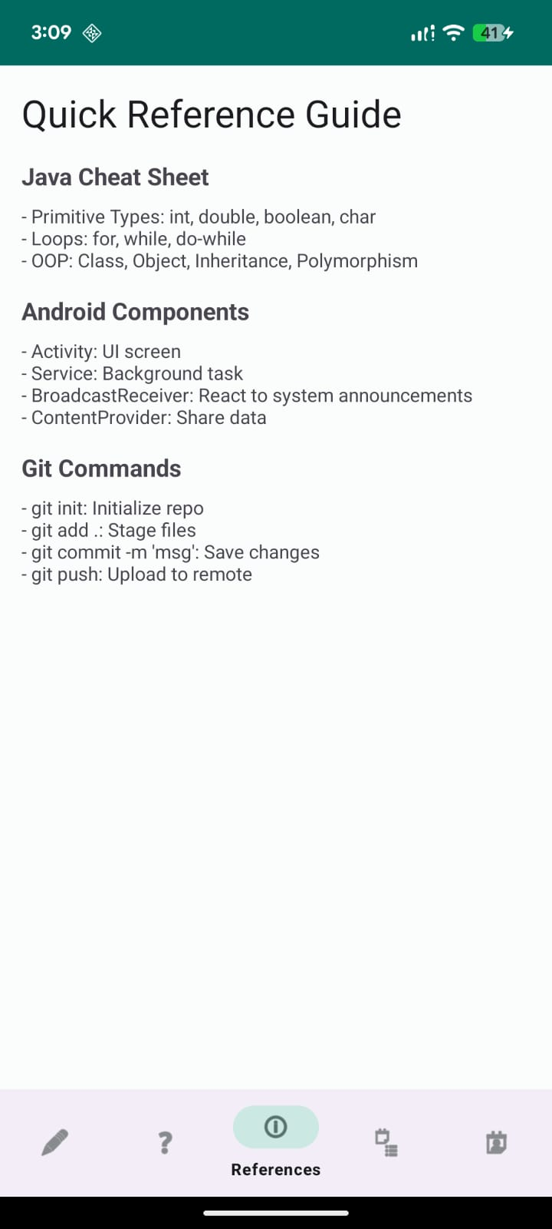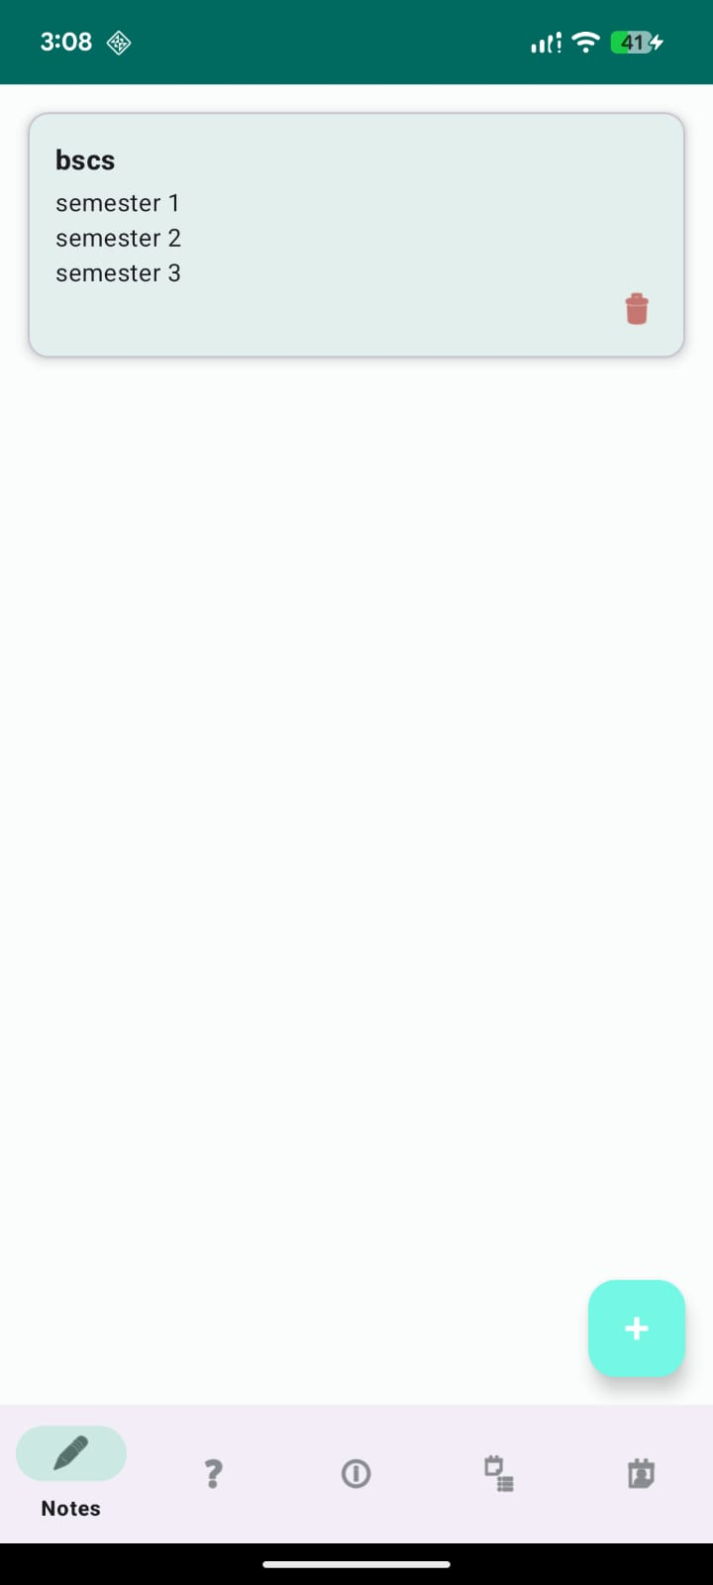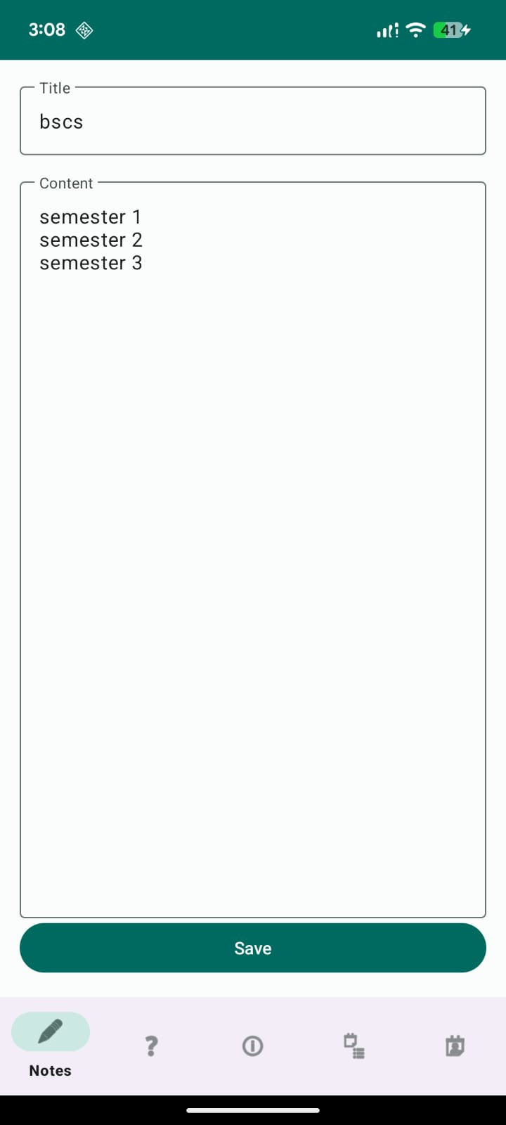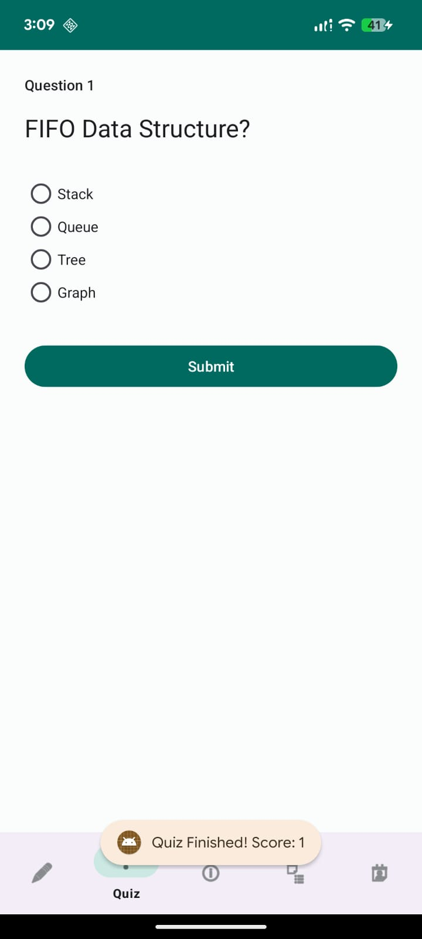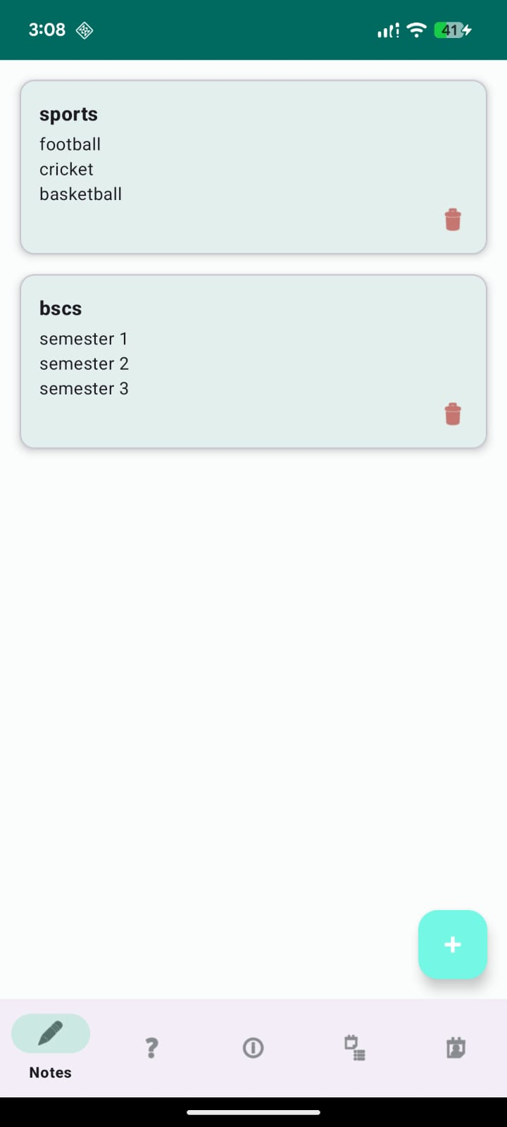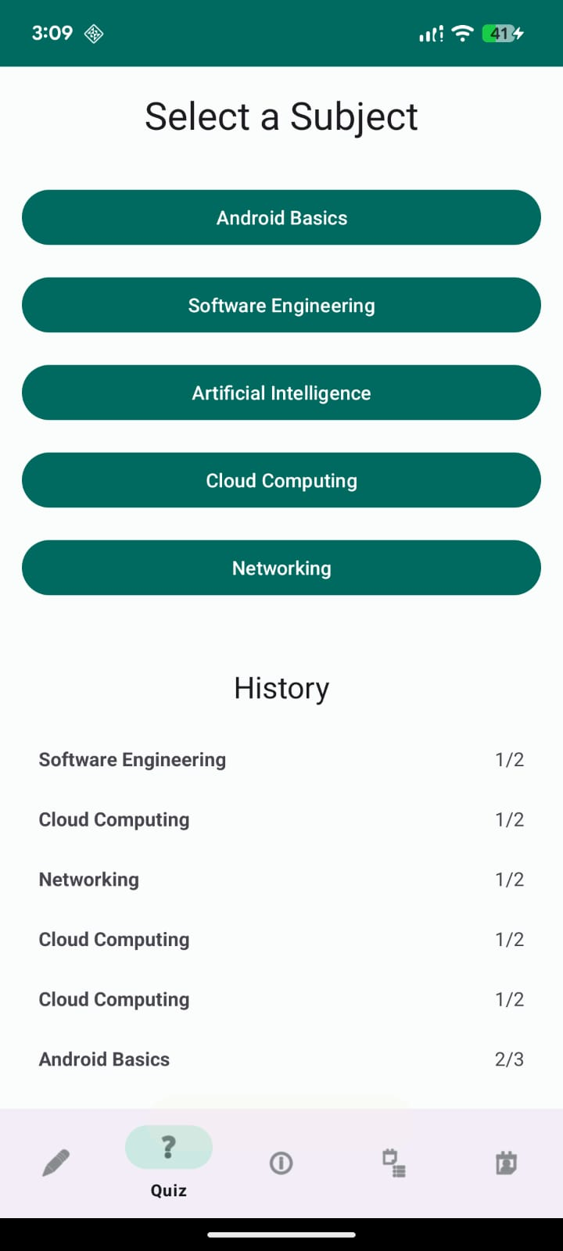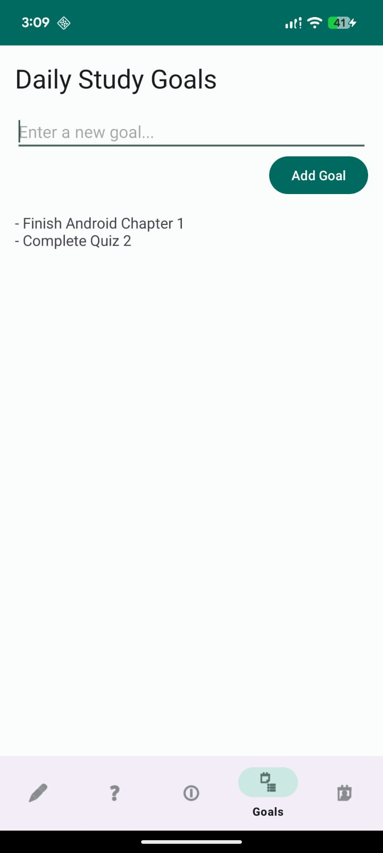

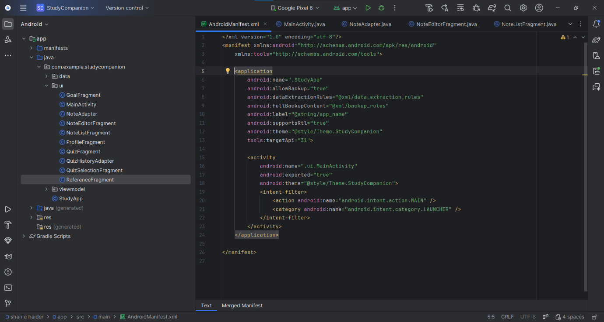
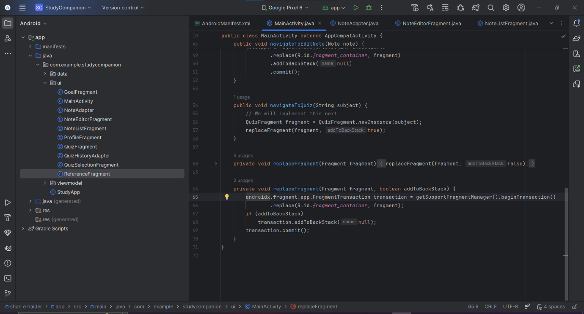

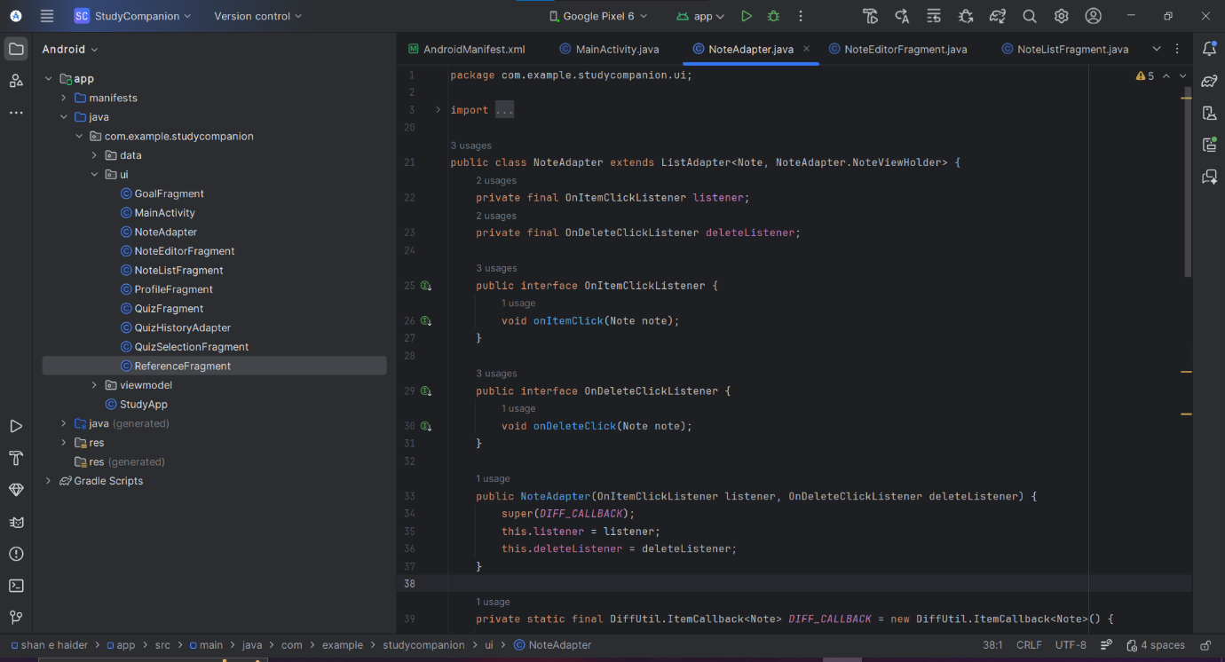

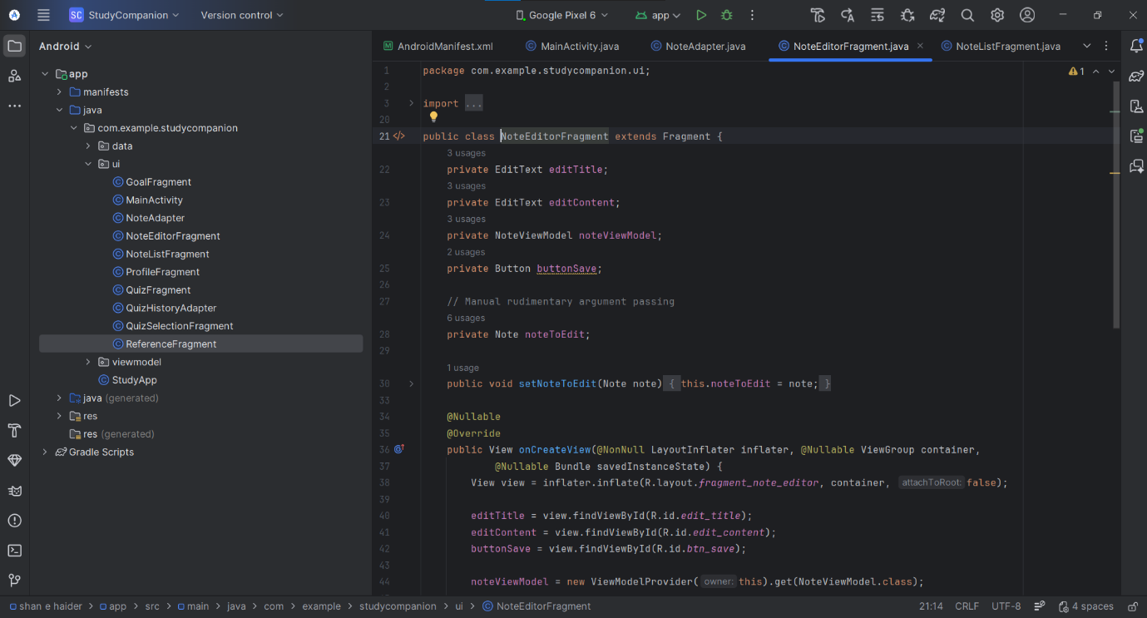
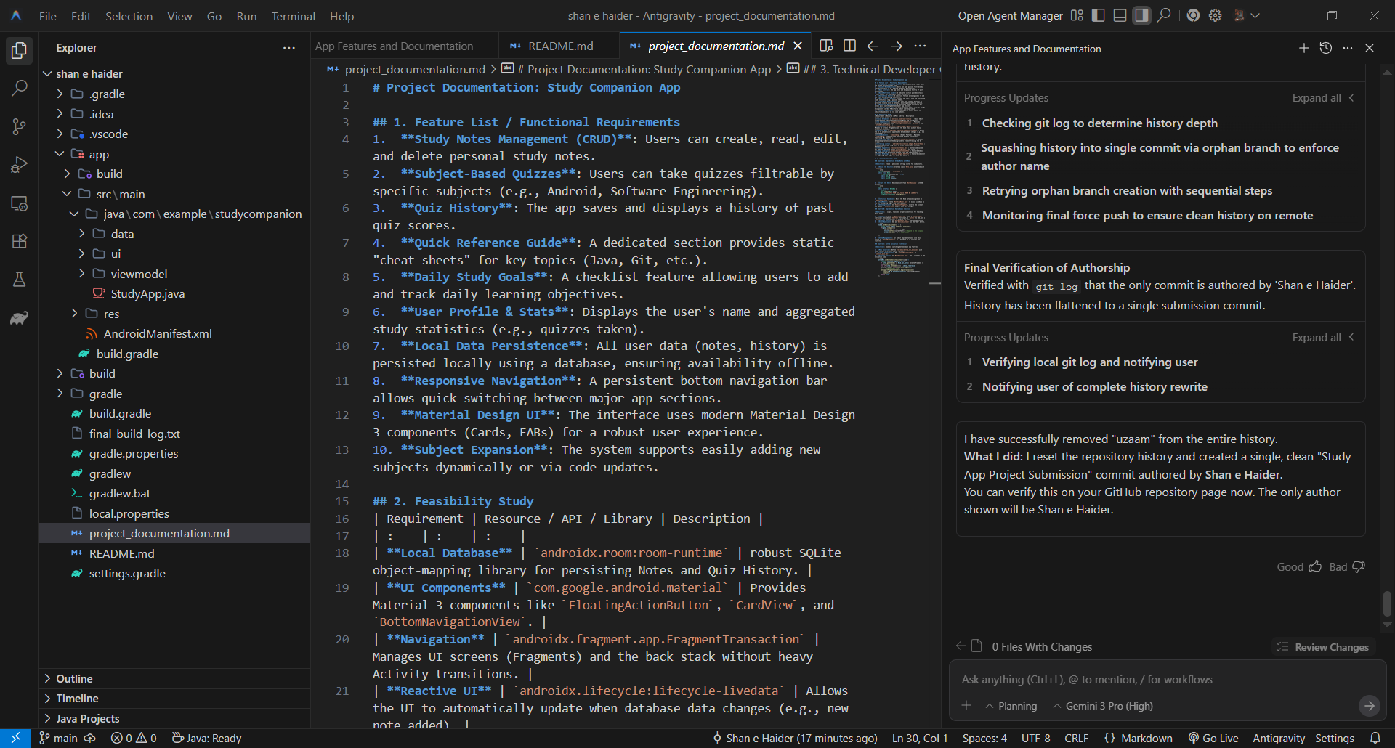

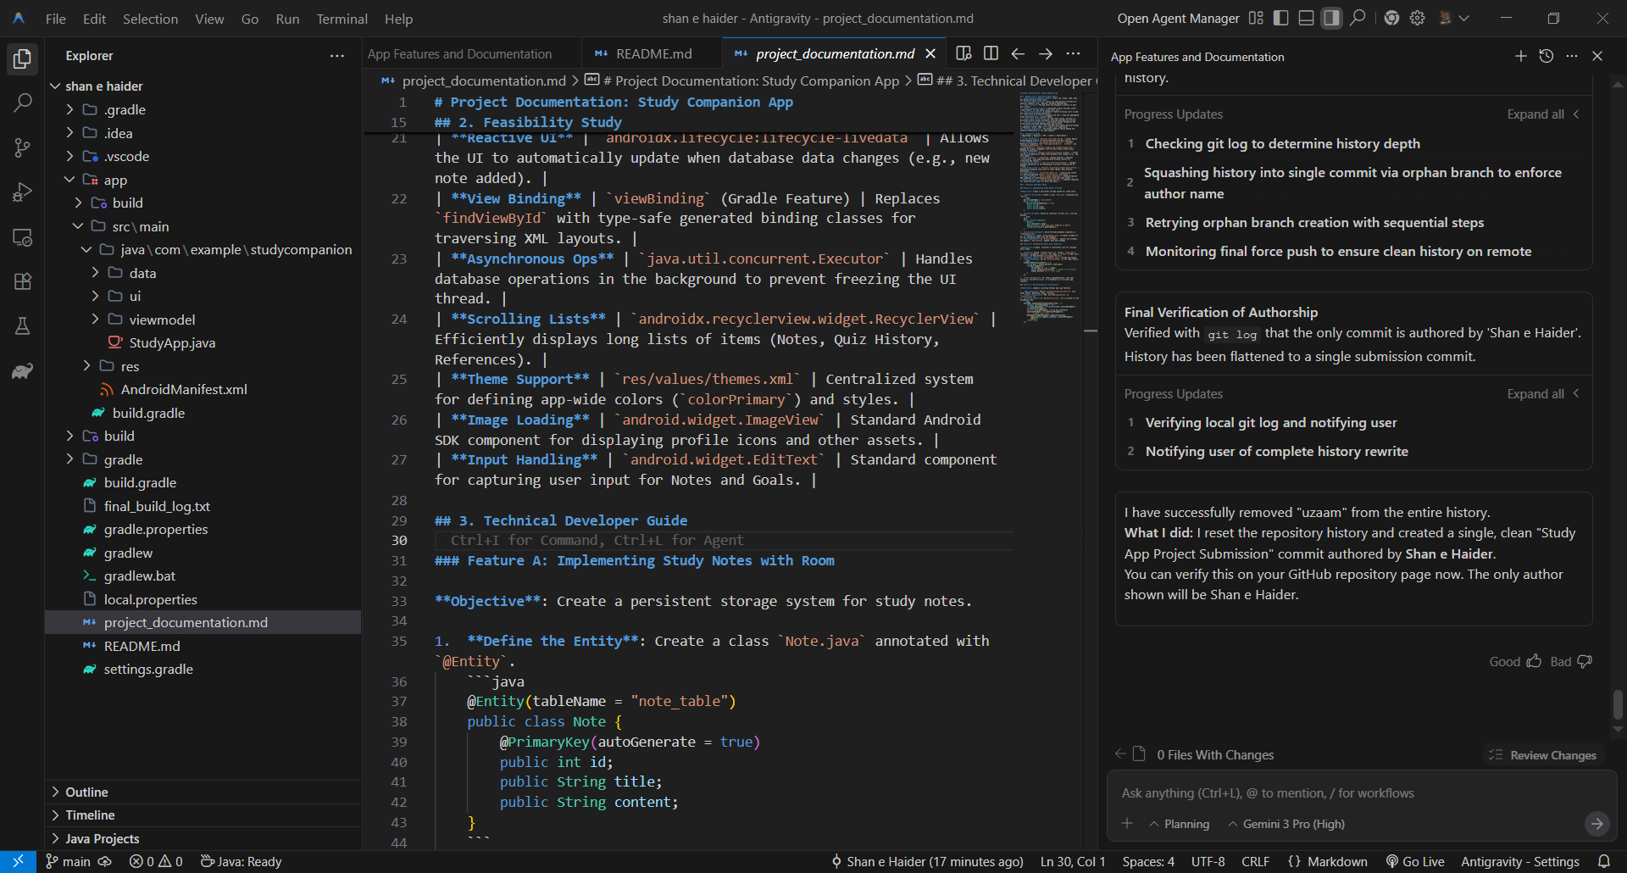

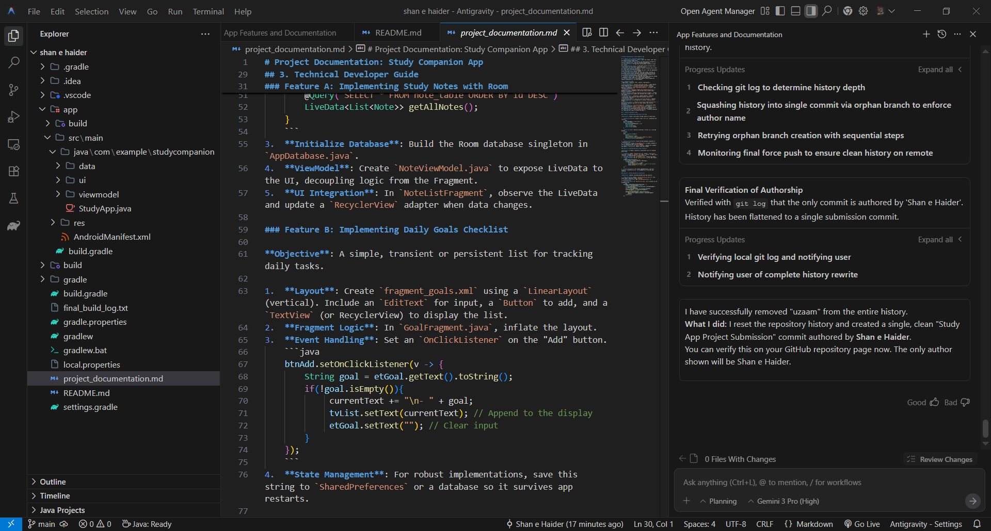

GitHub Repository Link
Paste the link here:
https://github.com/saqlain138/StudyNotesApp

